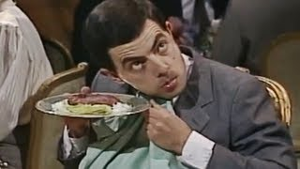
VIDEO ACTIVITY
Mr Bean at the Restaurant.
- How did Mr Bean surprise himself?
__________________________________________________________
- Why did he go to the restaurant ?
__________________________________________________________
- What did he order?
__________________________________________________________
- Why didn’t he accept more wine?
__________________________________________________________
- How did he make music?
__________________________________________________________
- Did he like the meat?
__________________________________________________________
- What expressions did the waiter use to ask Mr Bean about the food? Tick the ones
you heard.
___ Do you like the food, Sir? ___ Everything’s your satisfaction, Sir?
___ Is everything ok, Sir? ___ Is everything all right, Sir?
___ Are you Okay, Sir? ___ Are you sure?

- Where did Mr Bean hide the meat?
- _______________________ d) __________________________
- _______________________ e) __________________________
- _______________________ f) __________________________
- What song did the violinist play for him?
___________________________________________________________
- How did the waiter fall down?
___________________________________________________________
- According to Mr Bean, what happened when the waiter fell down?
___________________________________________________________
- Was Mr Bean happy at the end? Why?
___________________________________________________________
___________________________________________________________

